Friday, December 8, 2023, 1:30 p.m.
Zoom

SUMMARY

Business/Industry/Community Members Present:
Chau Chau Marcum, LLP, Senior Tax Accountant
TJ Delight Partner, NOW CFO
Minh Hoang Vice President of Financial Reporting, Tricon Residential, Inc.
Sabrina Landa Process Innovators, Principal Consultant/Accountant / CSULB Instructor

GWC Faculty/Staff/Guests/District Members Present:
Heather Antunez GWC, Counselor
Bern Baumgartner GWC, Instructor, Department Chair
Dorsie Brooks GWC, Dean, Business & Career Education
Angela Browne GWC, Instructor
Kevin Erdkamp CCC, Instructor, Department Chair
Arabian Morgan OCC, Instructor
Audris Nguyen GWC, Fortune CPA, Inc., CEO
Alice Rivera GWC, Instructor
Aleksandra Uchlik GWC, Instructor

The purpose of the advisory committee is to provide input and recommendations to the faculty and administration on changes in direction for the education programs. These recommendations include suggestions for improvement, expansion, student recruitment, innovation, and/or equipment commonly found in industry that is associated with the pertinent program.

CALL TO ORDER
Alice Rivera started the zoom meeting at 1:30 p.m. with committee members introducing themselves. Alice then shared a PowerPoint presentation.

VIDEO PRESENTATION
Dorsie Brooks shared a video produced by FutureBuilt.

LABOR MARKET DATA
Members viewed the Los Angeles/Orange County regional labor market data, provided by O*NET Resource Center, related to accounting occupations. (See attached.)

REVISIONS TO ACCOUNTING CERTIFICATE OR DEGREE PROGRAMS

- Enrolled Agent Tax Specialist Certificate of Achievement (Vote required.)

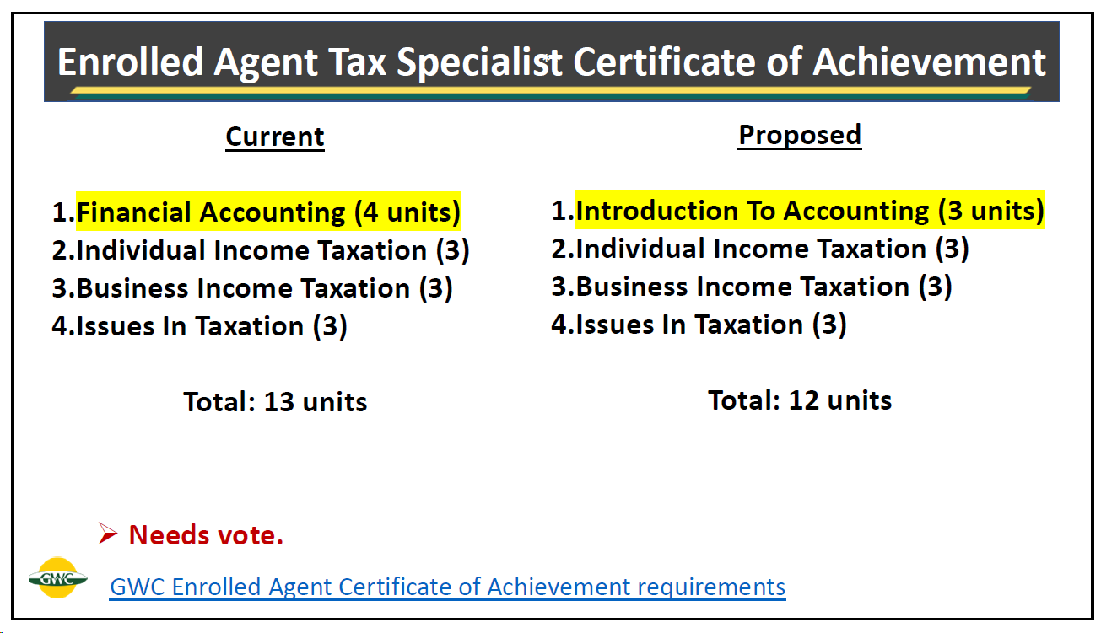
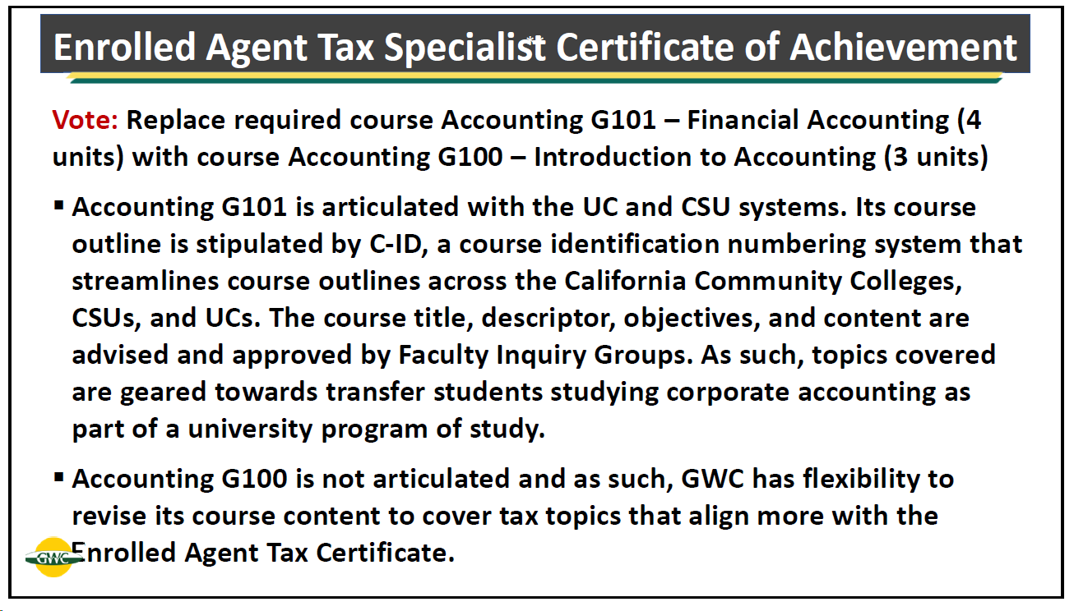

ACTION: The committee unanimously approved the proposed change to the Enrolled Agent Tax Specialist Certificate of Achievement. Accounting G101 will be replaced with Accounting G100.

- Bookkeeping Certificate of Achievement (No action required.)

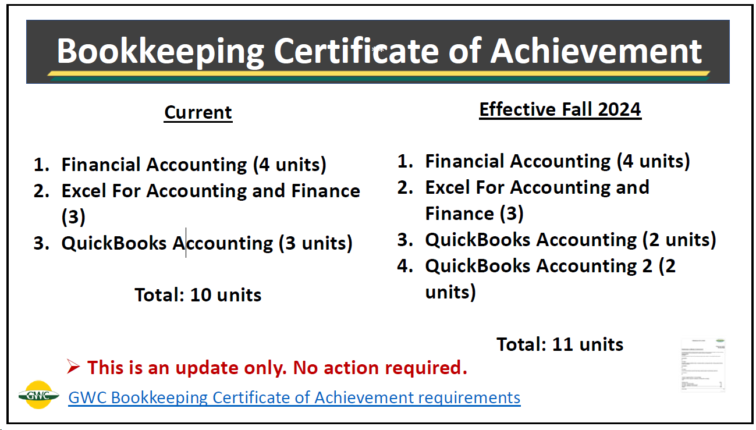

- Staff Accountant Certificate of Achievement (No action required.)

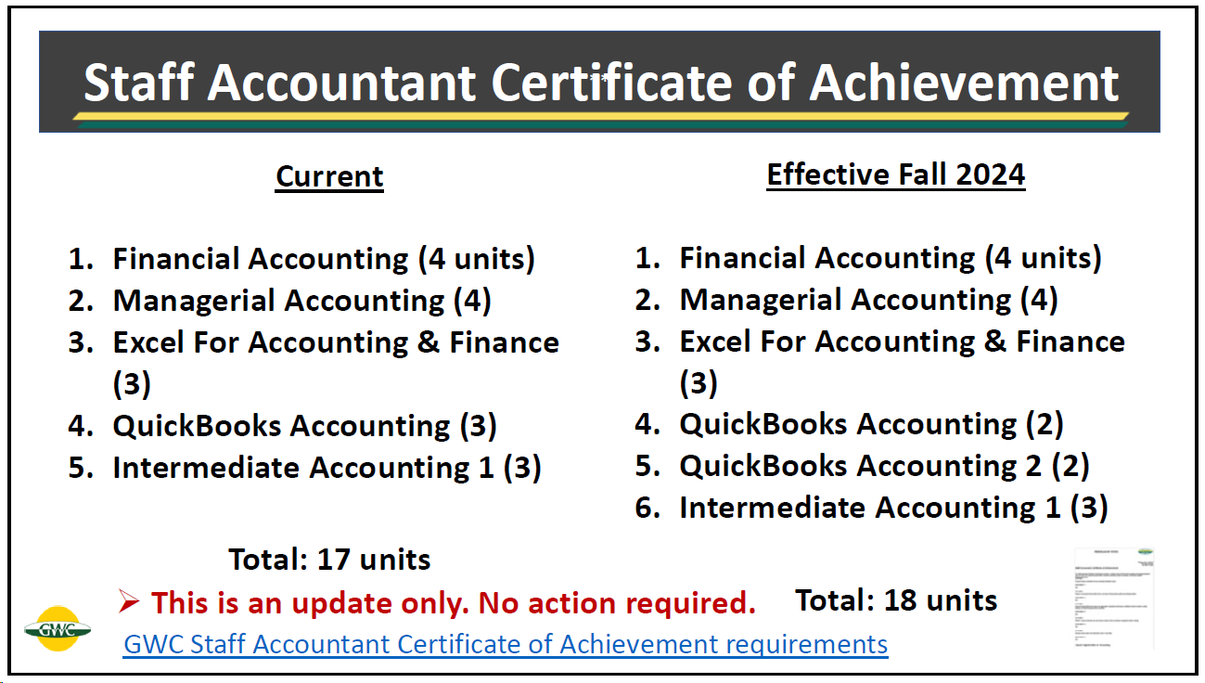

- Accounting Associate Degree (Vote required.)

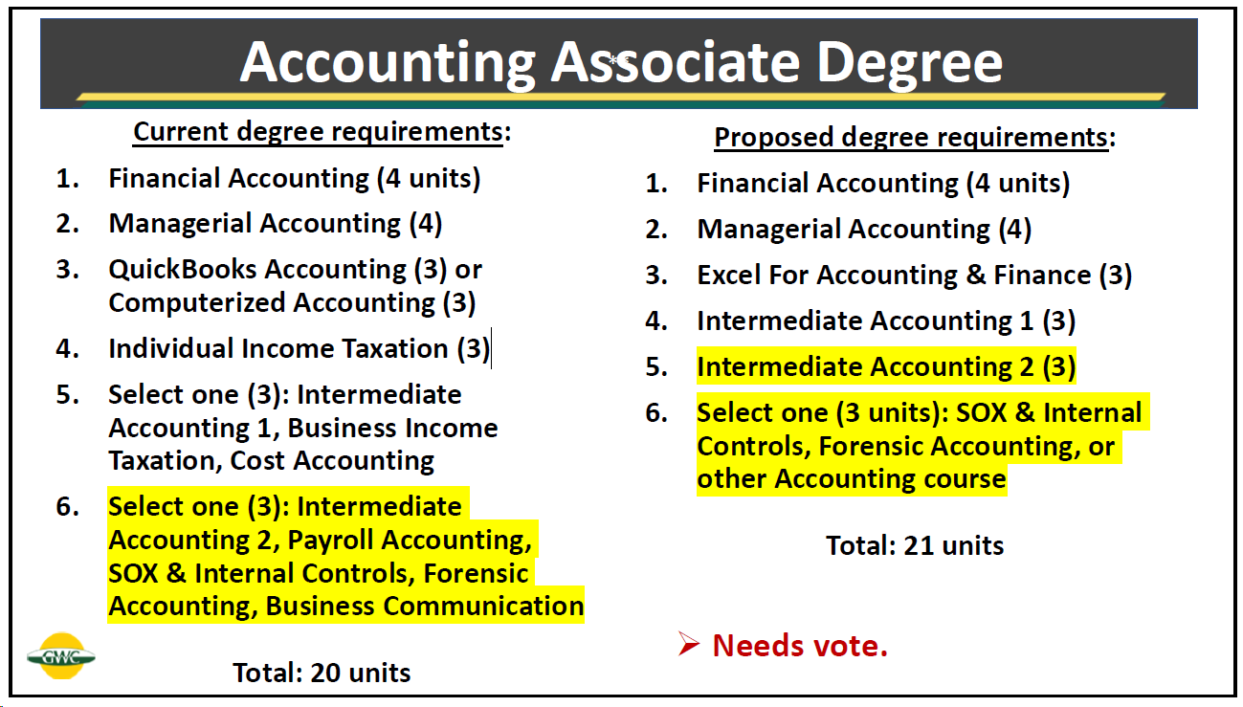

ACTION: The committee unanimously approved the proposed change to the Accounting Associate Degree as noted above.

NEW ACCOUNTING CERTIFICATE OR DEGREE PROGRAMS
Alice shared a preview of a third Accounting Certificate. See below.

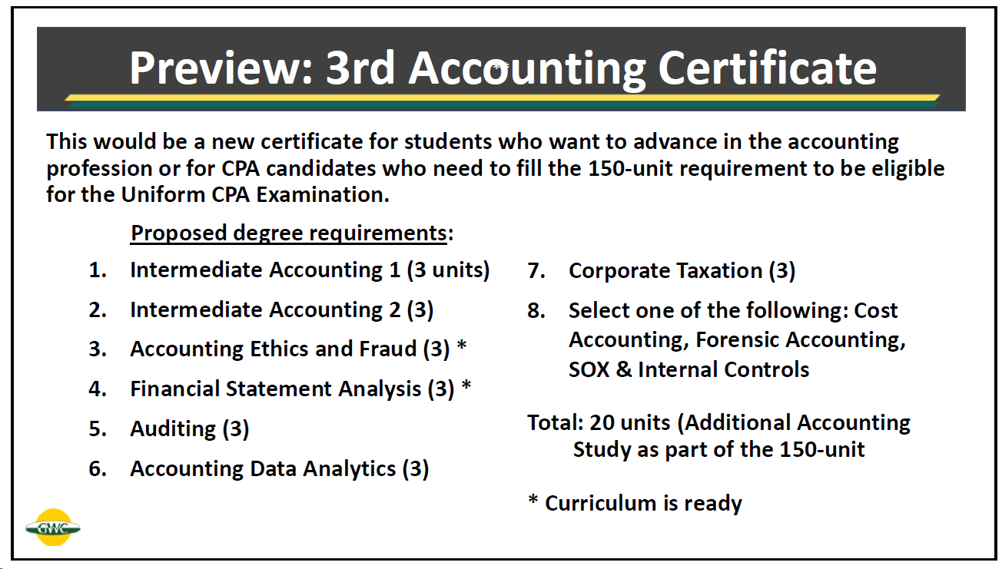

ADJOURNMENT
The meeting adjourned at 2:30 p.m.

